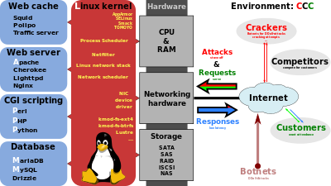

# **LAMP (Linux, Apache, MySQL, PHP):-**

**LAMP** is an [open source](http://searchenterpriselinux.techtarget.com/definition/open-source) Web development platform that uses [Linux](http://searchenterpriselinux.techtarget.com/definition/Linux) as the operating system, [Apache](http://searchcio-midmarket.techtarget.com/definition/Apache) as the Web server, [MySQL](http://searchenterpriselinux.techtarget.com/definition/MySQL)/MariaDB as the relational database management system and [PHP](http://searchenterpriselinux.techtarget.com/definition/PHP) as the object-oriented scripting language. (Sometimes [Perl](http://searchenterpriselinux.techtarget.com/definition/Perl) or [Python](http://searchenterpriselinux.techtarget.com/definition/Python) is used instead of PHP)

Because the platform has four [layer](http://searchsoftwarequality.techtarget.com/definition/layer)s, LAMP is sometimes referred to as a LAMP stack. Stacks can be built on different operating systems. Developers that use these tools with a [**Windows**](http://searchwindowsserver.techtarget.com/definition/Windows)operating system instead of Linux are said to be using **WAMP**; with a[**Macintosh**](http://searchcio-midmarket.techtarget.com/definition/Macintosh)system**, MAMP**; and with a[**Solaris**](http://searchenterpriselinux.techtarget.com/definition/Solaris) system, **SAMP.**

**Where do we use LAMP ?**

1. Step up **CMS-Content Management System** ( Wordpress, Drupal, Joomla, Codeigniter, etc., )

**WHAT IS THE DIFFERENCE WEB SERVER AND APPLICATION SERVER?**

**WEB SERVER:-** It is a collection of **Static HTML** pages

**HTML:-** Hypertext Markup Language ( Language of Tags)

**XML:-** Extended Markup Language ( User Defined Tags)

**Static pages:-**  the pages will not change with respect of time. **Ex:-** Wikipedia sites

**APPLICATION SERVER:-** It is a collection of **Dynamic** pages

**Dynamic page:-**The pages will change with respect of time **Ex:-** Banking sites.

**Business logic :-**

**Focus on specific Target /Area Ex:**Banking , Railway/Airline

**Technologies:-**

Servers: which depend on JAVA are Weblogic, Websphere, Tomcat, Jetty. Servers which don't uses java are Httpd/Nginx.

|  |  |  |
| --- | --- | --- |
|  |  |  |
|  | **Non- Java** | **Java** |
| Web Server | httpd(apache)/nginx | weblogic,websphere,Tomcat,Jetty |
| Language | PHP,Python,Perl,Ruby | Java |
| Example:- | Facebook,wikipedia | IRCTC,Banking |

**Apache (httpd):-**

**What is Apache Server (httpd) ?**

httpd is the Apache HyperText Transfer Protocol (HTTP) server program.

It is designed to be run as a standalone daemon process.

|  |  |  |
| --- | --- | --- |
| **Package name** | **httpd** | **mod_ssl** |
| Port number | 80 | 443 |
| Protocol | http | https |
| Server Dir | /etc/httpd |  |
| Config file | /etc/httpd/conf/httpd.conf |  |
| Document_root | /var/www/html |  |
| Logs | /var/log/httpd/error_log |  |
|  | /var/log/httpd/access_log |  |

**How to install the httpd service in CentOs?**

yum -y install epel-release

yum -y install httpd

**Command:**

**6.x**  RHEL/Centos

service httpd start/stop/restart ….

chkconfig httpd on

cat/etc/os-release

**7.x** RHEL/Centos

systemctl start/stop httpd.service

systemctl enable httpd.service

cat /etc/redhat-release

**How to check my httpd service is running or not?**

**6.x** service httpd status

netstat -ntpl | grep 80

ps -ef | grep httpd

**7.x**  systemctl status httpd.service

netstat -ntpl | grep 80

ps -ef | grep httpd

**How to check the conf file is correct or not?**

**6.x** service httpd configtest

Httpd -t

**7.x** httpd -t

**----------------------------------------------------------------------------------------------------------------------------**

**Installation of apache (httpd):-**

**# rpm -qa | grep http**

This command is used to check whether the http is installed or not. If present

**o/p:-** **httpd-tools-2.4.6-45.el7.centos.4.x86_64 httpd-2.4.6-45.el7.centos.4.x86_64**

**# rpm -qa | grep epel**

This command is used to check whether the epel extra packages has been installed or not.

**# sudo yum -y install httpd**

This command is used to install httpd files.

**# cd /etc/httpd**

This folder consist of all conf files like **conf ,conf.d, logs, modules, run** etc.,

**conf :-** httpd.conf ( old files removed using rpm command will present in it.) we can remove this.

**conf.d :-** phpMyAdmin.conf ,README, welcome.conf

**logs:-** ssl_eror_log, accesses_log, error_log etc cd /

**# sudo firewall-cmd --permanent --add-port=80/tcp**

This command is used to open the port number. **o/p :-** success

**# sudo systemctl start httpd**

This command is used to start the httpd

**# sudo systemctl enable httpd**

This command is used to enable the httpd

**# sudo service httpd status**

This command is used to check the status of the httpd

**# sudo netstat -ntpl | grep 80**

**# ps -ef | grep http**

Used to check whether the http has been installed or not

**Our process should run with non-root processes**

Goto web-Browser and open <https://serverip-servername/> **eg:-** http://104.197.181.201

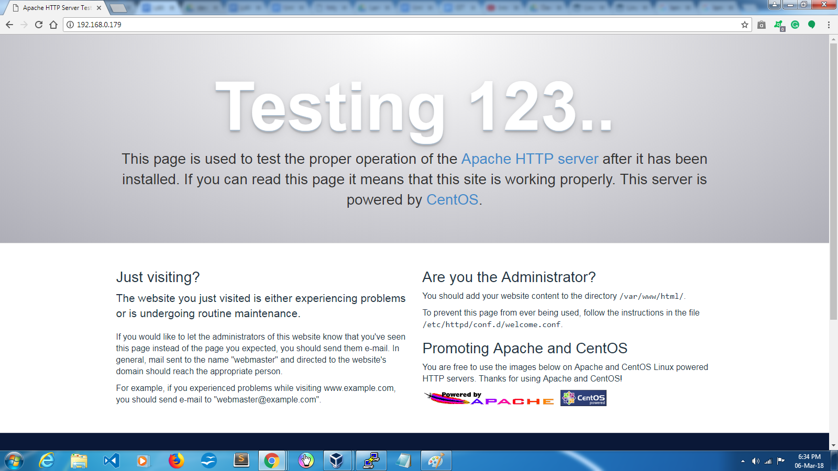

**->** Hit so the http -------> 80 all public server will go this and check and occupy this.

**->** goto  **/var/www/html** and check for the any index.html file is present or we can create a new html file . If we have not specified any path for the serverip . it will default take the index.html . and open the site we will able to see the site in that page.

<h1>web2web2.!</h1>

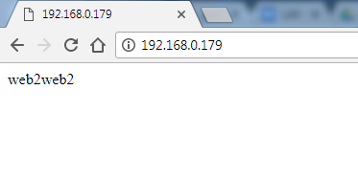

**Server** consist of boring code and so much of information.

**Browser** consist of page and colorful pages.

**----------------------------------------------------------------------------------------------------------------------------**

**Installation of php:-**

**Php:- Hypertext Processor Language**

**# sudo yum -y install php**

This command is used to install the php in the **cd /etc/httpd/conf.d/** as a **php.conf** file.

**Note:-** [**http://servname/sample.php**](http://servname/sample.php) **eg:- 104.197.181.201/sample.php**

It will connect with DNS server and then to the port number 80 then go to cd /var/www/html and search for any php pages .if present then it will run and show the result on browser.

simple .php ---> php engine ----> dynamic html page to the web server and then to browser.

**Creating a php file and try to run on the Browser :-**

Create a file in **vi /var/www/html/sample.php** and paste this code and save it.

**!DOCTYPE html>**

**<html>**

**<body>**

**<?php**

**$x = 1;**

**while($x <= 5) {**

**echo "The number is: $x <br>";**

**$x++;**

**}**

**?>**

**</body>**

**</html>**

**# sudo systemctl restart httpd**

Here we have to restart the httpd server to start the php .goto browser and run the

**# localhost/sample.php eg:- 104.197.181.201/sample.php**

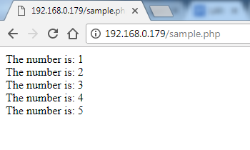

**----------------------------------------------------------------------------------------------------------------------------**

**Databases:-**

Types of databases MySQL, MariaDB,PostgreSQL, SQLite etc.,

But here we are discussion about the MySQL,MariaDB.

RHEL/Centos 6.x Mysql-server (oracle product)

RHEL/Centos 7.x mariadb-server

**Packages :** mysql-server , mysql-client

**Port :** 3306

**Conf file :** /etc/my.cnf

**Database Storage :** /var/lib/mysql

**DB engines :**  MyISAM(small memory usage), InnoDB(large memory

usage), Memory (for only memory usage)

**Log :** /var/log/mysql.log

**Commands:-**

**6.x Centos/RHEL**

Service mysqld start/stop

Chkconfig mysqld on

Service mysqld restart

Service mysqld status

**7.x Centos/RHEL**

Systemctl start mariadb.service

Systemctl enable mariadb.service

Systemctl restart mariadb.service

Systemctl status mariadb.service

**# ps -ef | grep mysql**

**# netstat -ntpl | grep 3306**

Show whether the mysql files are present or not.

**What are the different type of users in MySQL/MariaDB?**

ADMIN --root (this root is different from linux root user)

NORMAL -- balu, bhargav

**How to connect to the MySQL DB?**

**# mysql -u root -p (**if the DB is on same host)i

**# mysql -u root -p -h <server ip>** (if the DB’s are on different system)

**Databases ---> tables -----> useful information**

**----------------------------------------------------------------------------------------------------------------------------**

**Installation of MySQL:-**

**# rpm -qa | grep mysql-server**

This command is used to check whether the mysql server is installed or not. If present

**# sudo yum -y install mysql-server**

This command is used to install the mysql -server .

For the first time we don't have username and password to login. And for mysql we should provide a security.

**# sudo systemctl start mysqld**

This is used to start the mysql file for the first time. Here mysqld d is a demon

**How to set the MySQL password for the first time ?**

**/usr/bin/mysqladmin -u root password ‘new-password’**

Eg:- /usr/bin/mysqladmin -u root password ‘balu3m’

**# sudo systemctl restart mysqld**

This command is used to update the password details which we have set

**# mysql -u root -p**

This command is used to get into the **mysql >** ←-- this is mysql prompt

**Why we need a database ?**

If we have 1 million user they have been saved in /etc/passwd will be slow when compared to the database

-> The data is already pre-sorted.(the data is arranged in the ascending / descending order. )

-> The concept is called as indexing.

1. **How to see how many db are in my system?**

**mysql >** show databases; show the list of all databases

**mysql>** use <dbname>; you are choosing the DB to work

**Eg:-**  use mysql;

**mysql>** show tables; it will show the structure of the DB

**mysql>** describe <tabname>; it show us the table description

desc <tbname>;

**eg:-** desc users;

**2. How to choose data from the tables?**

**mysql> SELECT <field1>,<field2> FROM tablename WHERE condition**

**3. How to take the mysql backup ?**

**mysqldump -u root -p dbname > dbname.sql**

**Eg:- #** mysqldump -u root -p mysql > mysql.sql

Used to backup the mysql file

**# mysqldump -u root -p --all-databases > alldbbackup.sql**

**Eg:-** used to backup all the mysql file

**4. How to restore the backup?**

**# mysql -u root -p < mysql.sql or alldatabase.sql**

This command is used to restore the backup files we use **<** symbol

**5. How to restore mysql root password?**

1.Bring down the database service

2.start the DB in single user mode of MySQL

3.reset your password

4.stop the mysql service

5.start the service and login with new password.

**Step 1:-**

**# sudo service mysqld stop**

This command is used to stop the database service

**Step 2:-**

**# sudo mysqld_safe --skip-grant-tables &**

This command is used to set all the database to single user mode

**# mysql -u root**

This Command is used to login to mysql without any password.

**Step -3**

**# mysql > UPDATE <tablename> SET field=value WHERE [condition]**

This command is used to set the new password for the existing user

**# use mysql;**

**Eg:- SELECT User , Host, Password FROM user WHERE User = “root”;**

**# flush privileges;**

**# exit**

**Step 4:-**

**# sudo systemctl stop mysqld**

This command is used to stop the mysql services

**# ps -ef | grep mysql**

Check whether the mysql is running or not .. it should be in stopped. If it is working then kill the processes

**Step 5:-**

**# sudo systemctl start mysql**

this command restart the mysql and new password is updated

**# mysql -u root -p**

Now we can log in with new password. Successfully we have updated password

**How to get GUI connectivity to MySQL DB?**

phpMyAdmin

**# yum -y install phpmyadmin**

We have to install the phpmyadmin package. In the /etc/httpd/conf.d/phpMyAdmin.conf we can access this with the apache service.

**#** Goto **/etc/httpd/conf.d/phpMyAdmin.conf**

Add the ip address of the site into the **Allow from** point. And save it

**# sudo systemctl restart httpd**

Restarting the httpd services

**# localhost/phpMyAdmin or <ip address>/phpMyAdmin**

In the browser we can see the phpMyadmin page.